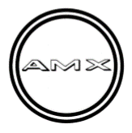
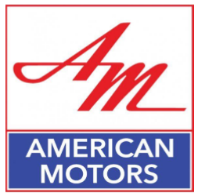
1969 A9M397N259455

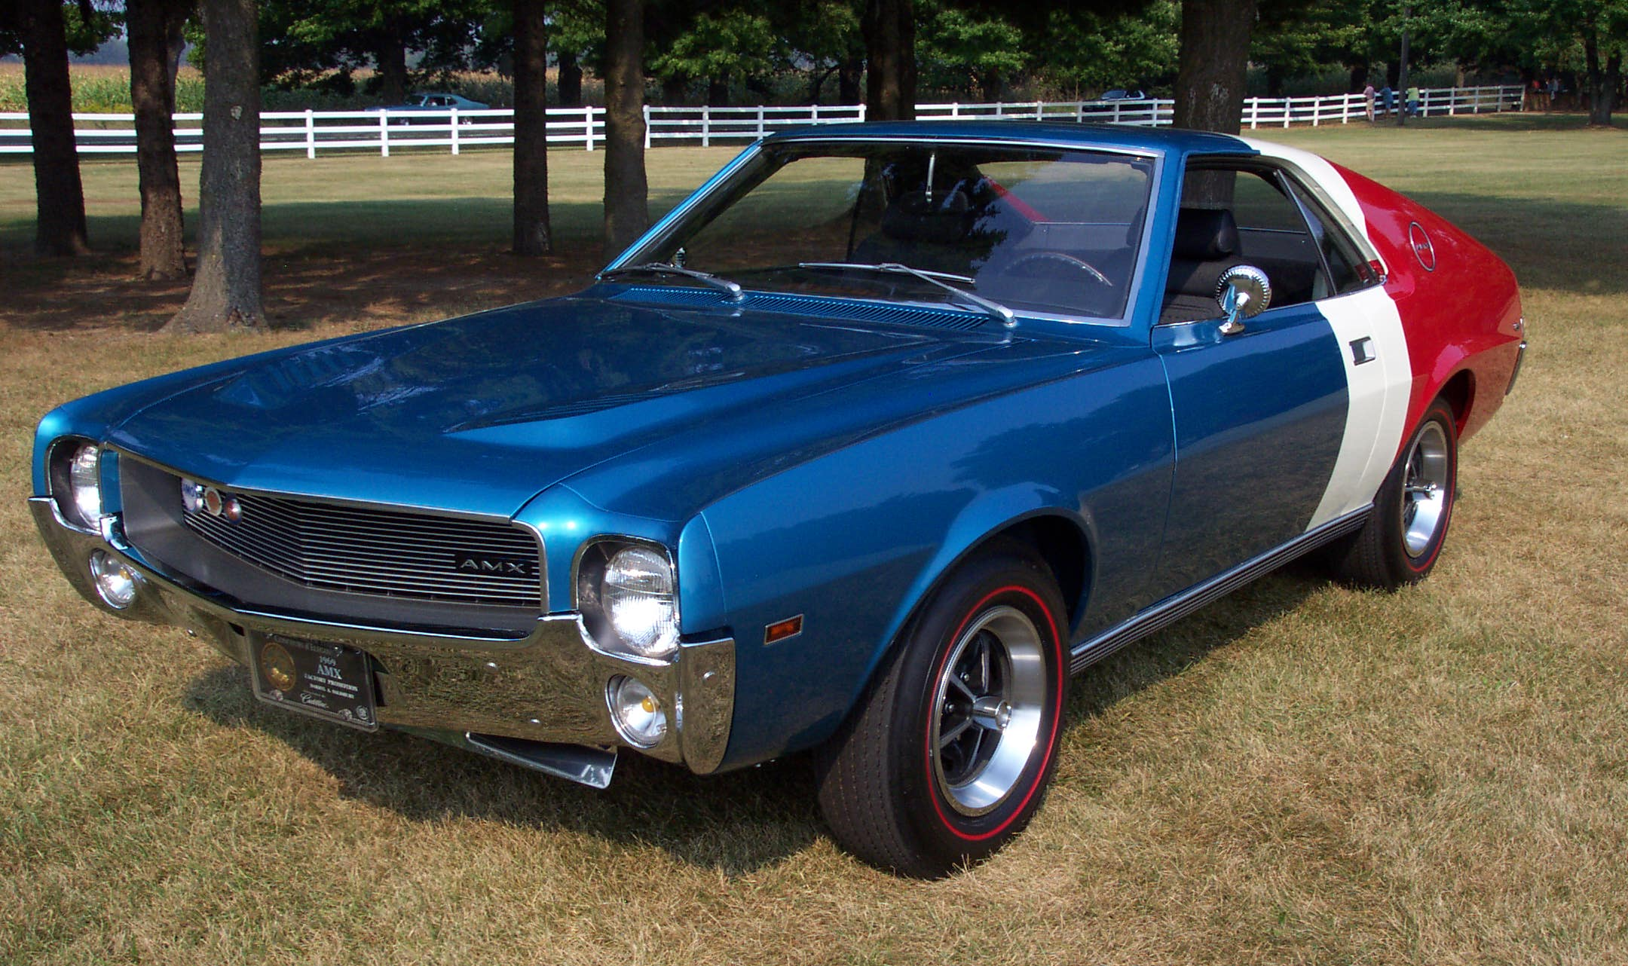
Owned by
Darryl A. Salisbury
Since 1984

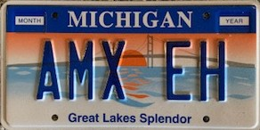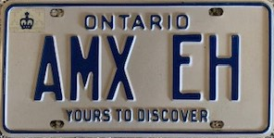

AMC Shows Its Colors on a One-of-a-Kind AMX

When American Motors Corporation was formed through the merger of the Nash-Kelvinator Corporation and the Hudson Motor Car Company on May 1, 1954, the corporate colors became red/white/blue…a natural step with the company name in mind. As the company began to approach the performance era of the late 1960s and early 1970s, the red/white/blue color theme began to permeate the paint schemes of many specialty cars produced by AMC at the time.
The late 1960s through the early 1970s was a time of drastic change for the American automobile industry. Studebaker, after its absorption of Packard, had died a slow, agonizing death, and American Motors Corportation was determined to meet the challenge head on. AMC was rapidly coming out of the economical, basic transportation mode led by then AMC President George Romney. It was Romney who pioneered the compact car in the form of the Ramber American, to set the pace for the smaller, more economical “cars of the future.” AMC, or Rambler, had built a corporate image of just such cars. While the AMC engineers knew what was going on in the market, the old school management of AMC was highly reluctant to make any changes to its lineup.
The big three were aggressively forging ahead with engine size and horsepower as the leading sales tools. Each company tried to outdo the others with these numbers as the driving forces. With the advent of the new Mustang from Ford (1964½), a whole new market niche was established—a personal sports car at an affordable price, made in America, and designed to perform on American roads. GMC and Chrysler were quick to jump on the bandwagon. AMC, well, that took a bit longer. New management, slumping sales, and a rude awakening to reality, put AMC on the hot seat and changes had to be made if the corporation were to survive.
AMC’s entry into this new market niche came in the form of the Javelin for the 1968 model year. The Javelin had unique styling, performance, and appeal—just the qualities needed to make a mark in this new market area. Plus, it did well on drag strips, on oval tracks, and in the new Trans Am racing series. And, the company even provided technical and financial backing for many of these ventures.
As time progressed, AMC went far beyond this modest introduction into the market with some pretty radical make-overs. The 1969½ SC/Rambler, the 1970 Javelin Trans Am, the 1970 Rebel “The Machine,” and the 1971 Hornet SC/360 (not done in the corporate red/white/blue colors) were offered as examples of company-produced modifications of base models. All four of these unique cars were available for purchase through many of the AMC dealerships. They grabbed the public’s attention through unusual advertisements (i.e. “This Rambler does 14.2 @ 98 mph in a quarter,” for the 1969½ SC/Rambler) and radical paint schemes, many of which exhibited the red/white/blue coporate colors.
Paralleling the development of these special cars was the introduction and promotion of AMC’s new two-place sports car, the AMX, on February 15, 1968. This was the first real two-place American-built sports car to come on the scene since the Corvette (1953+) and early Thunderbird (1955+). It was another radical step by AMC to compete in this ever-growing muscle car market. And, it was only possible because AMC had borrowed many parts from its sister car, the Javelin, thus allowing for a much lower overhead in pre-production. While AMC never sold the numbers it had hoped for, the AMX made a very profound impression on the public, and has continued to do so in its own special way for some fifty years hence.
AMX Production Numbers
1968 – 6,725
1969 – 8,293
1970 – 4,116
Total – 19.134
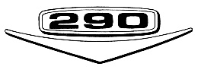
The corporate image for the AMX started with Craig Breedlove and wife, Lee, in Texas in 1968. Two specially prepared 1968 AMXs, one a 390 CID V-8 (No. 1) and the other a 290 CID V-8 (No. 2) were campaigned at an oval race track in Texas owned by Goodyear. The No. 1 car (painted red/white/blue, Scheme 1) was to set 16 land speed records in 24 hours, while the No. 2 car (painted blue/white/red, Scheme 2) was to set 90 land speed records for the same 24 hours. This was an endurance test for both cars and drivers. The resulting records were to last for many years.
The second image for the AMX was that of quarter mile jaunts. Hurst, in conjunction with AMC, built up 52 SS/AMXs designed for drag racing only. In some states the cars were not even eligible for a title or license plates as they were designed

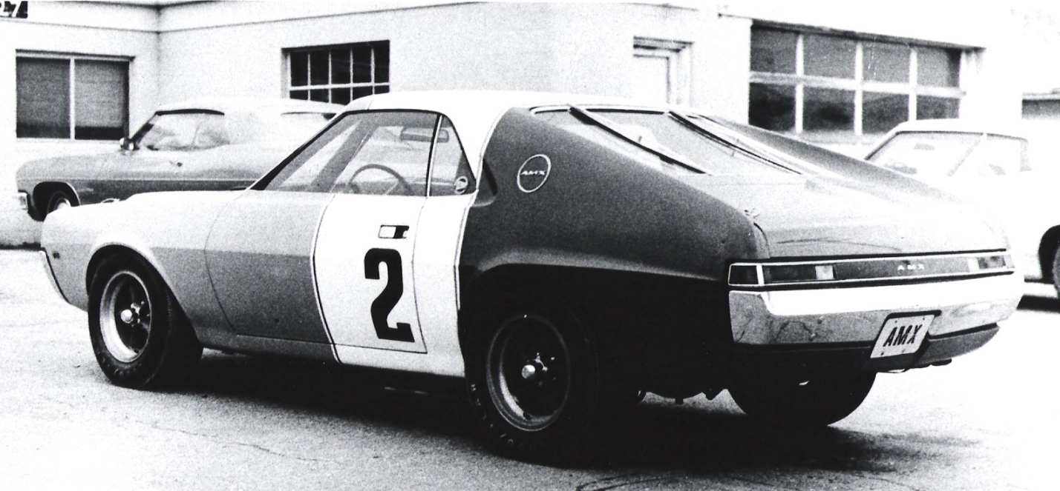
Original Breedlove No. 2 AMX

for “quarter mile endurance tests only.” I owned one at one time and the State of Michigan refused to take my money for a title. I was, needless to say, astounded. These scarce AMXs went to dealerships around the country and were campaigned by the dealerships and private owners, making the AMX a real contender on the drag strip.
With both images in place, a well-established line of performance cars with proven records, and the overwhelming desire to be different, AMC had entered the field of high performance with a bang. The SS/AMX owners were advised by AMC to use its red/white/blue corporate colors to make a lasting impression. And, most did. So, why not use this newly established reputation as a spring board for sales and promotion?

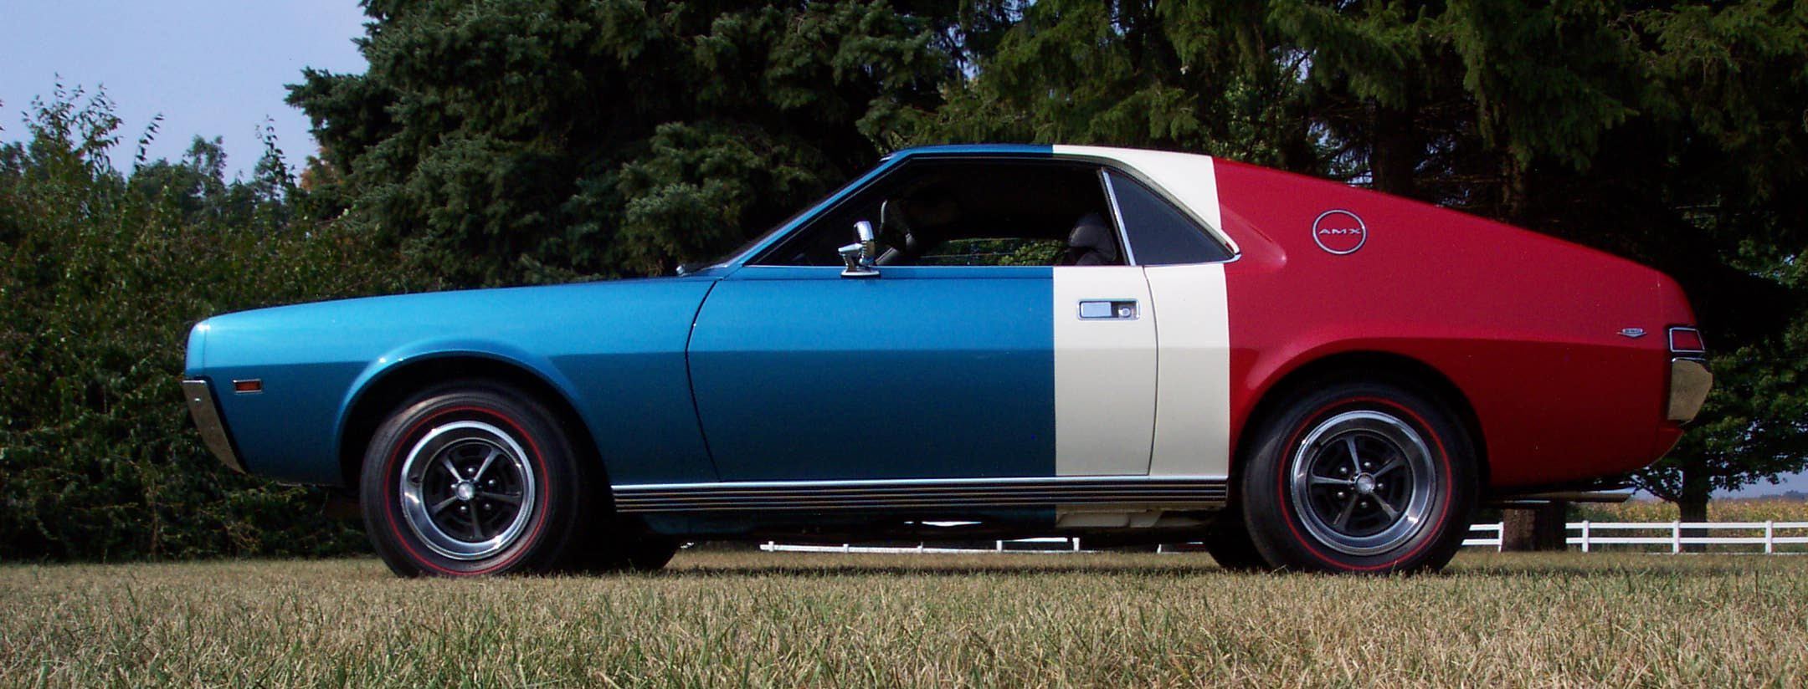

Scheme 2: Caravelle Blue / Frost White / Matador Red

And then there were the stories and rumors about red/white/blue factory- produced this, and red/white/blue factory-produced that. As in all such realms, very few of such stories and rumors produced actual cars. In order to validate any red/white/blue paint scheme as factory-produced, door tags and build orders were the only acceptable verifications. The build orders needed to indentify the special paint scheme and the door tags needed to verify such with a “00” (1969 and earlier) or “SPCL” (1970 and later) paint code. Many dealers and individuals painted their cars with the corporate colors, but were unable to verify them as factory painted tri-color cars.
Since the late 1960s, I have been heavily involved with AMC cars and in the AMC car club scene. Early on, rumors about red/white/blue paint scheme cars were popular in casual conversations. I clearly recall seeing Domino’s Pizza Javelins done in red/white/blue, running around delivering pizzas at the time (why hasn’t someone restored one of these?).
In the 1970s and 1980s, I lived in Portage, Michigan (adjacent to Kalamazoo), about two blocks off of I-94. The annual AMO (American Motors Owners Association) International Convention was held, appropriately, in Kenosha, Wisconsin, about 3½ hours west along I-94 around Lake Michigan and through Chicago (that was an interesting and challenging drive each year). By the early 1980s, it had become a unique tradition for the AMO+ (formerly the Classic AMC/AMX Club of Central Canada) club members to stop by for a barbeque and a “couple of beers” on the Thursday evening on the way through to Kenosha the following day. It was always a special event for me as I got to see some great people with their special AMC cars.
One such evening in 1981, on the way to Kenosha, Harm and Barb van der Veen and a couple of other friends/AMC enthusiasts from Canada showed up for the annual barbeque, all excited (more than normal). They produced a copy of a build order for a tri-colored AMX. They knew the owner and had seen the car. I was excited as well, as finally one of the aforementioned car rumors had come to fruition. Needless to say, I was anxious to see the car and talk to the owner.
This finally happened in the early spring of 1982. I was at a university-sponsored conference in Toronto (I taught at Western Michigan University) and had asked the AMO chapter people there to facilitate a visit with the owner and his car. It was dark, cold, windy, and rainy…typical of a mid-March evening, all negative aspects when you want to look at a car. To make things more challenging, the garage in which the AMX was stored was old and had no electricity. To further compound the situation, the flashlight which was finally located, barely worked as the batteries were low. The end result was that I was interested in purchasing the car. I left with little hope in doing so.
Flash forward two years. The owner of the AMX was getting a divorce and the car had to go. Ken Perrier (of Canada) was also interested in purchasing the car. When I heard this I felt that any chance of my getting the car had completely vanished. The people in the Classic AMC/AMX Club of Central Canada (now AMO+), an AMO chapter, met, discussed the purchase of the car at length, and then made their decision. Ken Perrier agreed with the group. I was called and informed that they all wanted me to get the car as they thought I would do the restoration well and the car would be brought back to better than its original condition.
I contacted the owner, discussed the car, and came to an agreement on a price. I immediately visited my bank for a loan and got the money transferred. Now to get the car home! Harm and Barb van der Veen (great friends to have once again) and Ken Edwards (all of Canada) decided to make the trip to Portage, Michigan, one weekend with the newly purchased AMX. They were somewhat concerned about the border crossing and had some contingency plans, but never had to put them into action. They showed up with the car with its Canadian (Ontario) license plates. The following day, they took the license plates and returned home. That was just the beginning.

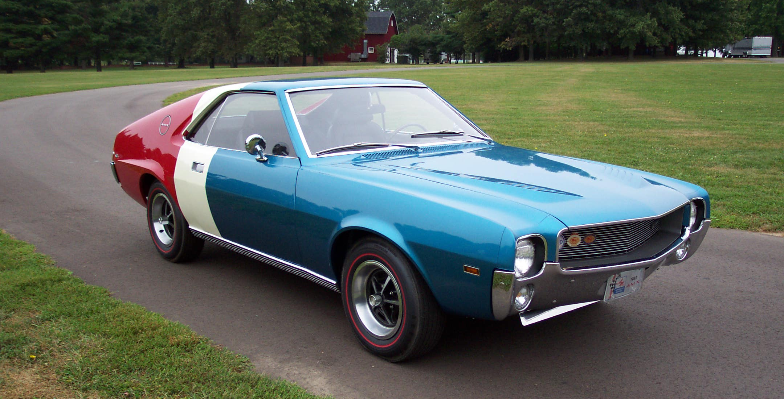

1969 AMX Factory Promotion

I immediately went to the Michigan Secretary of State office to transfer the title, buy license plates, and pay the requisite tax on the purchase of the car. The new license plate was “AMX EH” respecting its Canadian history. Nothing else was required, which surprized me (it was 1984).
This special AMX appeared to be a factory replica of the original No. 2 Breedlove AMX. The AMX was a bit rough. The seats were all beat out with springs protruding in spots; the carpet turned out to be one layer on top of another and all ragged out; there was an after-market radio installed with an antenna hole drilled right in the middle of the trunk lid; the hood had a burn spot right above the carburetor indicating a malfunctioning carburetor at one time in its history; it had after-market wheels and tires which needed replacing badly; the engine had been painted a bright blue; the pocket areas between the quarter panels and the trunk base were packed full of wet residue from the trunk mat and anything else that had been in the trunk (it was a wonder that the quarter panels were not rusted through); the headliner was in rough shape; the windshield was cracked; and the list went on. All of this notwithstanding, the car was driveable, and I did so for the first year or so of its life under my ownership. It went unrestored to a variety of car shows around my area of Michigan just to show that there really was a factory-built tri-color AMX.
Finally came the long process of restoration. For some unknown reason, I had begun accumulating new parts long before I even knew this car existed. I had purchased a complete air pollution system, including the pump, from my local AMC dealer (this, along with the original stickers, is what is on the car now). Addtionally, I had purchased original rearview mirrors, a complete set of stickers for the engine compartment, and various other such parts, all of which were to come in handy during the restoration process. By that time, the car was around two decades old, and NOS parts were either unavailable or quite expensive, and reproduction parts were basically nonexistent.
I had Dan’s Auto Body (no longer in business) of Plainwell, Michigan, do the body and paint. We had already pulled the engine and removed the interior. Both the hood and trunk lids were replaced with NOS items. The original trunk lid was the only location where rust was detected, and that was along the bottom rim. Talsma’s Upholstering of Plainwell, Michigan, reupholstered the two front seats. Bob Saeger, also of Plainwell, Michigan, rebuilt the engine and did the remainder of the restoration. I had asked Bob to do this as I knew his work quality was second to none, and he, too, was an AMX enthusiast. And he didn’t disappoint me…
the AMX turned out to be better than new!
An interesting anecdote here is that once we took the carpet out and checked out the rest of the car, we learned that the Goodyear E70x14 Redline Tire
car had been painted blue/white/red all the
way around to include the undercarriage and the complete interior by the factory.
It was not a white car, painted blue in the front and red in the rear as the Ontario (Canada) government had thought. They had registered it as a white car. This find made the project all the more interesting.
Bob jumped into the project and worked diligently, seemingly forever. He did everything in his own very meticulous manner, and it showed when you looked over the car. He had created a masterpiece far superior to what AMC had produced originally. I vividly recall going over to see him from week to week, providing him with money to pay the accumulating bills, and continuing to encourage him on his path to perfection. If you were to ask me how much I had invested in this project, I could not begin to answer. It was various amounts of money at various times to whomever was working on the car at the time.
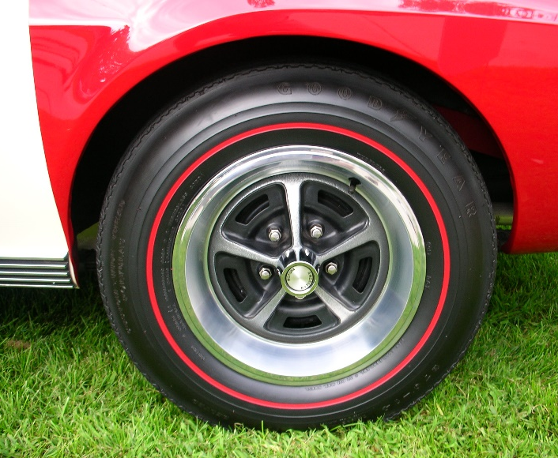
Parallel to and before this restoration project, I was very interested in trying to get the Goodyear redline tires reproduced (Goodyear was the sole supplier of tires to AMC at the time). I was able to get in touch with John Kelsey of Kelsey Tire, Inc., of Camdenton, Missouri, to facilitate the reproduction of the tires. Kelsey Tire was the only company with authorization to reproduce older Goodyear tires, so this was the only route to take. I started the process in 1986. Finally, after many years, in 1993, Kelsey Tire proceded to work on the reproduction Goodyear redlines. Then, one day after I returned home from school (Western Michigan University), I found a set of four Goodyear redlines on my porch. No note…no bill…so I called John Kelsey to find out how much I owed him. His response was that, “…anyone as dedicated to such a goal as you have been, deserves to receive a free set of tires.” Not only did I get the project rolling, but I was able to ensure the tires were up to the standard needed and finally produced for restoration projects like mine (see the letter at the end of this story).
In doing research on the AMX (I do as an educator) to support its history, I was fortunate to run into the son of the dealer, John Wellman (Wellman Motors, 64 Jones Avenue, Oshawa, Ontario, Canada), at a car show. The son immediately recognized the car and came over to me to talk about it. He shared with me that after the dealership ceased to exist and his father had passed, he had inherited a multitude of boxes containing sales and other data pertaining to the dealership. I shared the VIN with him and he went home to search. The following day he contacted me with great information—he had found the pink back-up slip of the window sticker (a straight bill of lading – short form – original; see end of story) along with a few other pieces of pertinent data. Also included in that data was a letter to Wellman Motors Limited from American Motors (Canada) Limited, which stated that the AMX was given away through a contest held by S.C. Johnson & Son, Limited, Brantford, Ontario. The winner of the AMX was Muriel Sillen, 89 Elizabeth Crescent, Whitby, Ontario. The AMX was given away at a Can-Am race at Mosport International Raceway in Bowmanville, Ontario, Canada, on 1 June 1969. He was happy to send everything to me to help me provide documentation for the AMX.
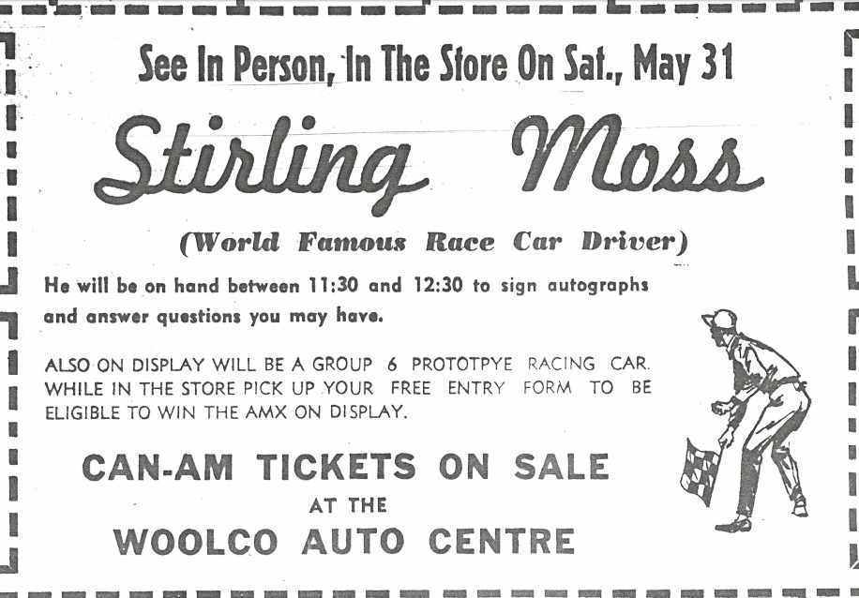
Along this same time period, I had been doing what I could to locate information pertaining to the history of the car. At a library in Oshawa, I was able to locate a copy of a newspaper at the time, with an ad referring to the car being at a local mall on display before the race at Mosport Race Track, where it was to be given away in June 1969. The car was to be a factory give-away, promoting AMC in Canada. From conversations later on, I learned that it was won by a lady who couldn’t drive a stick, so was quickly sold and passed on through three other owners prior to my acquisition thereof (heresay, no proof).
Anecdotally, as I was continually doing research on this special AMX, trying to learn all I could about it, I came across an individual named Peter Carson who lived in Portland, Oregon. Peter and I exchanged email messages and I learned that he had found and purchased an AMX with the Scheme No.1 paint application. The AMX was red/white/blue with Matador Red, Frost White, and Polaris Blue (not Caravelle Blue like mine), all supported by a “00” door tag paint code. This AMX was the 390 CID engine version. It, like my AMX, was a car with only basic options—no radio, no power brakes or steering, etc. Its VIN is A9M397X189879 and its dash plaque number is AMX 05999.
The Canadian AMX came equipped with a 290 CID, 4V, 225 hp. engine coupled to a four speed transmission. The factory options listed on the window sticker include the 290 CID engine, a four speed transmission, 00/00 paint code, vinyl trim no. T-931F, and E70x14 2 ply 4 ply rated redline tires. The car also came equipped with the new-for-1969 five spoke wheels with trim rings (the 1968 wheels were chrome and had no trim rings). The dealer, or someone along the way, had added the passenger side companion rearview mirror and a front, underbody, stainless steel spoiler offered by AMC as a Group 19 (factory high performance parts) item. Another unusual aspect of the car was that the blue used was actually called Caravelle Blue, a metallic turquouise and a 1968 color (this turquoise was also used on Shirley Shahan’s Drag On Lady SS/AMX). Both the Matador Red and the Frost White were listed as 1969 colors and non-metallic, although they were holdovers from 1968 and earlier. The AMX had no power steering, no power brakes, and even no radio (finding a factory radio block-off plate was a real challenge). So, the car was basically the cheapest AMX the factory could make for this give-away promotion.
SPECIAL TRI-TONE PAINT
1969 AMC – P39 RED
1969 AMC – P72 WHITE
1968 AMC – P44 BLUE
SCHEME NO 2

Accomplishments

The restoration on this special, one-of-a-kind AMX, was completed just days before the AMO International Convention held in Kannapolis, North Carolina, on July 18-20, 1997. Bob Saeger and family carefully transported this special AMX all the way there from the Kalamazoo, Michigan, area, where we both live. At its first AMO showing, it scored 199 points (out of 200) and moved up to the Senior Division. Next, at the AMO International Convention in Kenosha, Wisconsin, on July 22-25, 1998, it was awarded the Richard A. Teague Award for being the best AMX in the Senior Division, moving it up to the American Heritage Cup Class. Then, finally, at the AMO International Convention in Kingston, Ontario, Canada (its homecoming debut), on July 3-6, 2008, the AMX won the coveted American Heritage Cup.
This special AMX did equally well at many AACA (Antique Automobile Club of America) events since its restoration completion. It achieved a Senior First Place award at the AACA Eastern Fall Meet in Hershey, Pennsylvania, in 2000. It then moved up to Grand National First Place at the AACA Grand National Meet in Moline, Illinois, in 2001. The Grand National Senior award was won at the AACA Grand National Meet in Cedar Rapids, Iowa, in 2003. Following this, it has won Grand National Repeat Senior Awards two more times in 2007 at Hickory Corners, Michigan, and in 2019 at Auburn, Indiana. Another prestigious win was at the AACA Ontario Region, 26th Annual Autofest, in Oshawa, Ontario, Canada, where it won the Best of Show Award over some 50 cars.
Other notable accomplishments include being on a couple of calendars, being in articles in a couple of car-oriented magazines, and winning high level awards at a multitude of different level car shows. Owning this AMX has been a real joy!
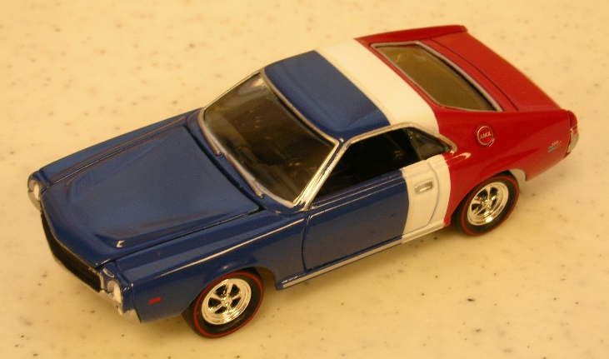
Two special models of this AMX have been made and were available to the public for purchase. The first of the two is a 1:64 scale model offered by Johnny Lightning in a multi-pack, thus not individually packaged. Johnny Lightning had contacted me about the colors and the breaks in the colors.
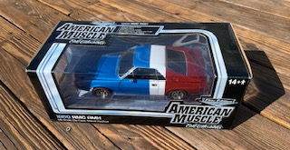
The second model is a 1:18 metal diecast by Ertl Collectibles American Muscle, in an individual package. Ertl had contacted me much earlier about an SS/AMX model. My response was that quite a few of such models had already been produced; why not do a tri-color AMX which is a real car (which I own)? They responded positively and asked for data to support the production. I forwarded a variety of pictures of the car along with paint code names and numbers. After a few months of waiting, the car finally came on the market. In both cases, the blue sections were not the correct Caravelle Blue (metallic turquoise) rather more of a Regatta Blue (medium to dark blue). And, probably not really a surprise, I was not offered a free model in either case. But, both models are quite unique in that they quite realistically represent the real car, and I always have the models on display with the car at all car events.

A special “THANK YOU” goes out to:
~ Harm and Barb van der Veen, Ken Perrier, Ken Edwards, and many more of
the great people in the AMO+ chapter in Canada (formerly the Classic
AMX/AMC Club of Central Canada);
~ Bob Saeger for his expertise and enthusiasm in doing the major part of the
restoration work on the AMX with exquisite precision and in minute detail;
~ Dan’s Auto Body for the excellent body work and paint;
~ Talsma Upholstering for the seat upholstery work; and
~ WiSeon Salisbury, my wife, for putting up with my fanaticism with this special
AMX

Not only has this special AMX won many prestigious accolades, it has also been honored to be a frequent display car at the Gilmore Car Museum (one of the top three car museums in the nation; North America’s largest auto museum), Hickory Corners, Michigan. Its unique license plate,”AMX EH,” brings attention and honor wherever the AMX is displayed. It has been a great personal pleasure to own this car over the past decades, and I look forward to sharing it through a variety of venues in the future. This is one AMX which will keep the corporate colors and image alive for many years to come.

Decoding the VIN
A = American Motors Corporation
9 = 1969
M = Manual Transmission, 4 Speed Floor Shift
3 = 30 Series (AMX)
9 = Two Door Hardtop
7 = Trim Level (AMX)
N = 290 CID/4V, 225 hp. Engine
259455 = Sequential Build Number (Starting with 100001)

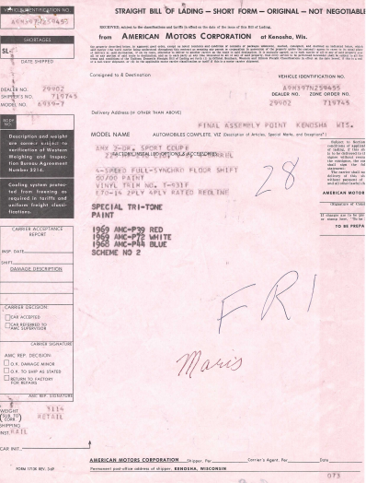
A special letter from John Kelsey, President of Kelsey Tire, Inc.
